# INTRODUCTION

# Overview

Event management is the application to manage and development of festivals, events and conferences. Proposed work Involves study of identifying the target of budget, cost, and analysis. This is an online event management system, software project that serves the functionality of an event manager. The project provides most of the basic functionality required for an event. It allows the user to select from list of event types. Event Management System is very helpful for events.

# Purpose

This application being as a platform to know the events, to apply for the events. Event organizer is an application under project management for managing festivals or social events like gathering, colleges, events, conferences etc. by this application user can register the students, after registering, user can login, after login, event details including name,contact, address, venue of the event, date, event conducting time, cost of events etc.

# Problem Definition & Design Thinking

# Empathy Map

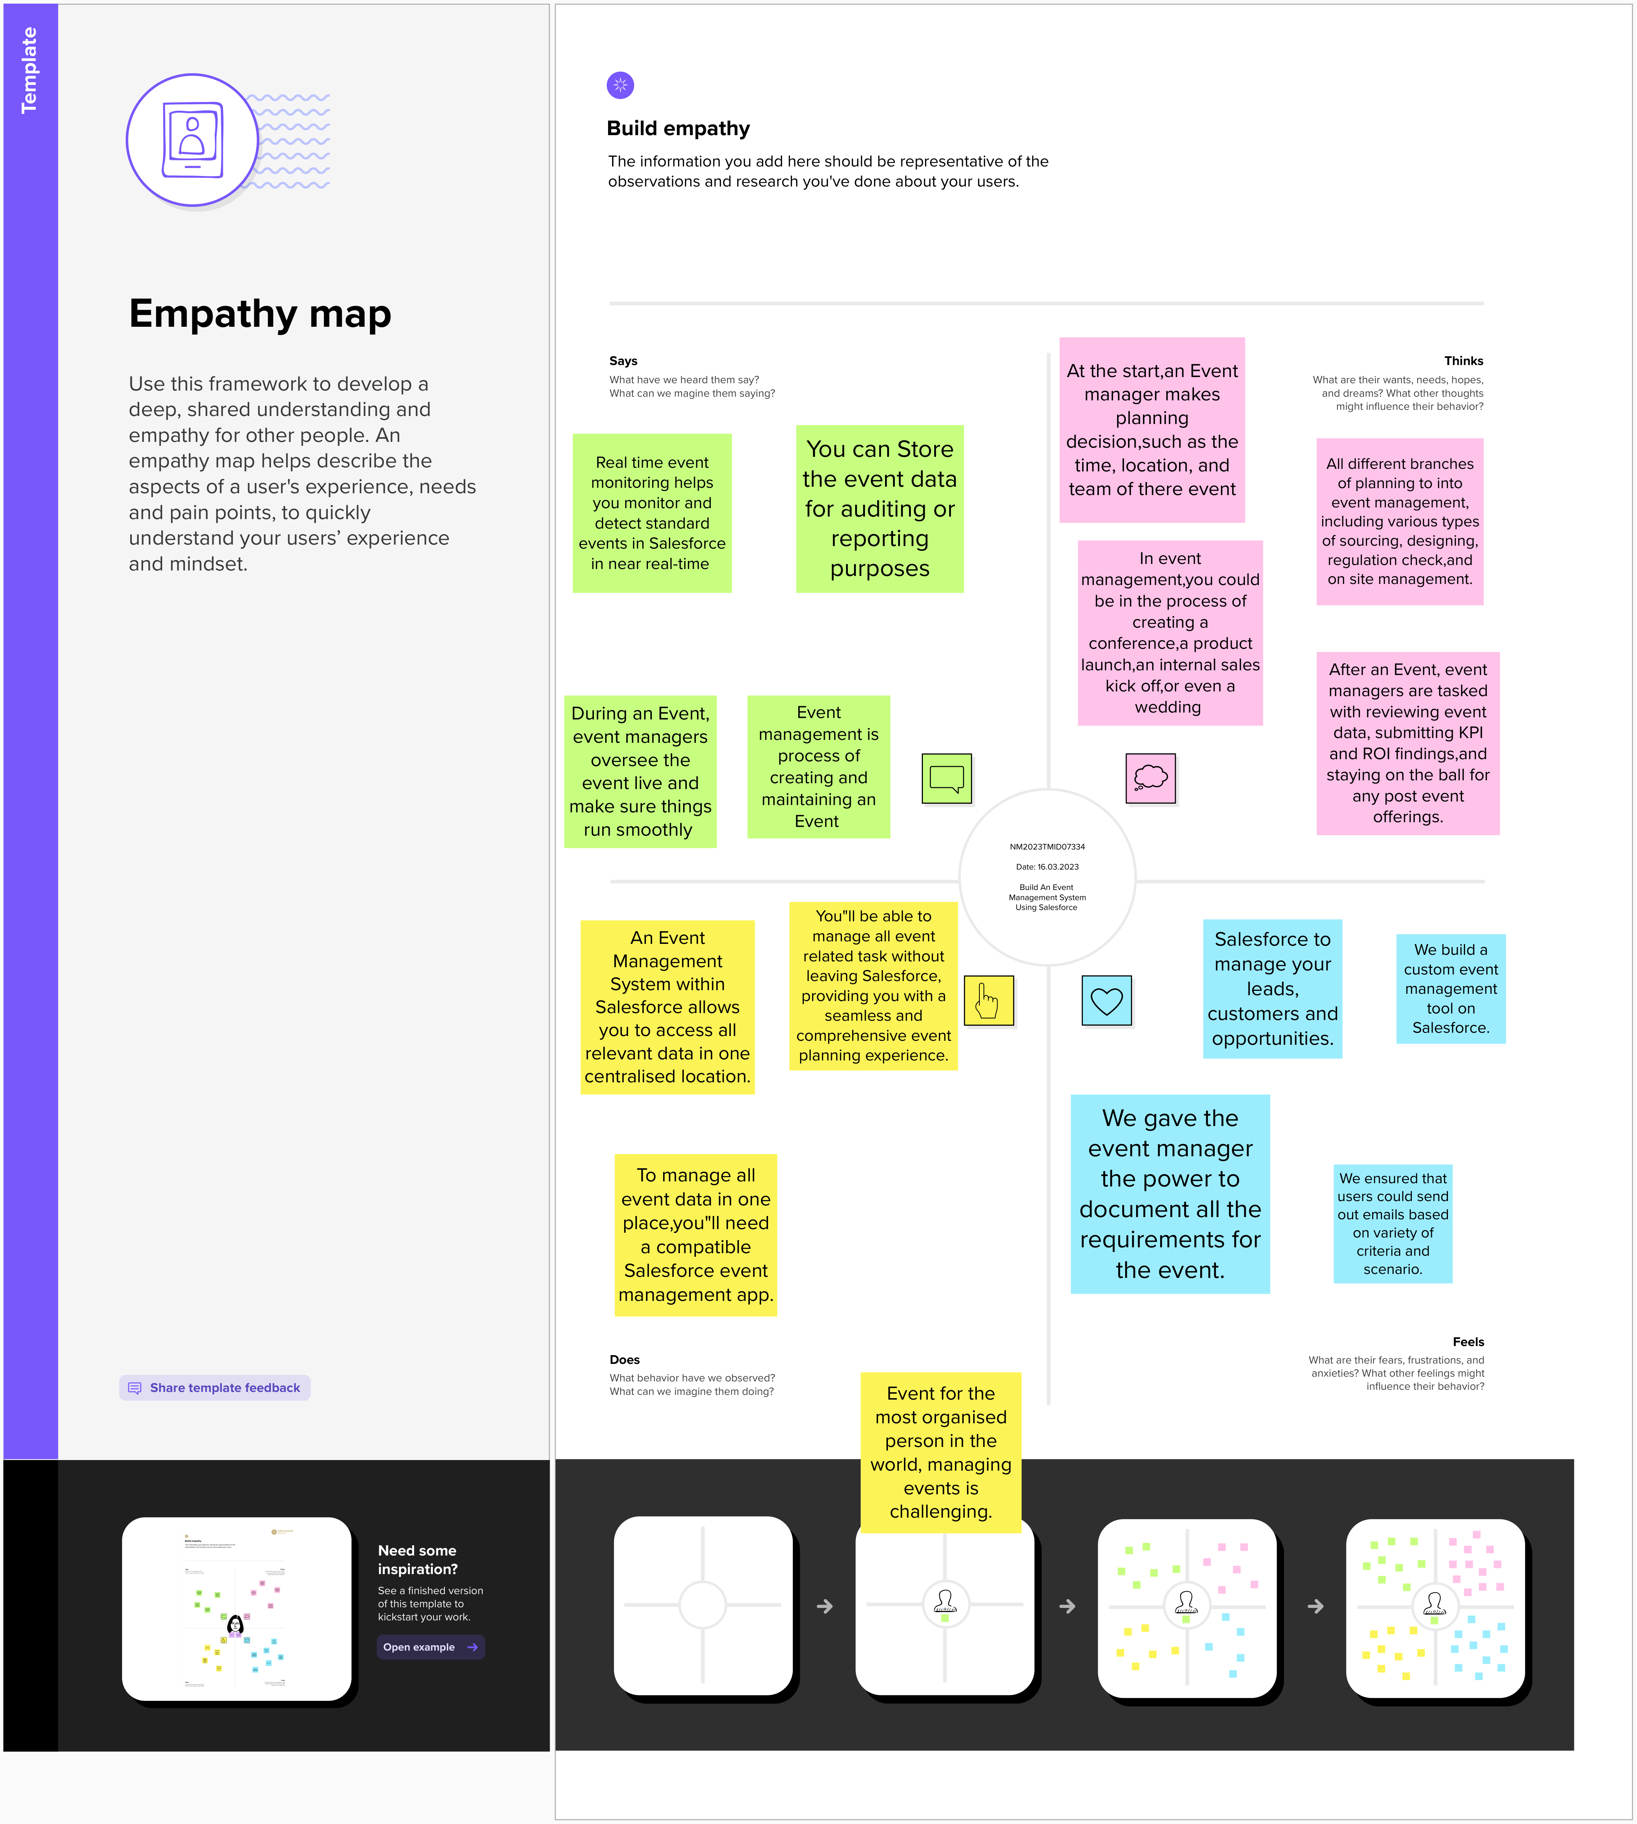

# Ideation & Brainstorming Map



# RESULT

Data Model:

|  |  |
| --- | --- |
| **Object name** | **Fields in the Object** |
| Attendees | |  |  | | --- | --- | | Field label | Data type | | Enter ID | Auto number | | Phone | Phone | | Email | Email | |
| Speakers | |  |  | | --- | --- | | Field label | Data type | | Bio | Text area | | Email | Email | |  |  | |
| Event | |  |  | | --- | --- | | Field label | Data type | | Event Name | Look-up relationship | | City | Text | |
| Vendors | |  |  | | --- | --- | | Field label | Data type | | Email | Email | | Phone | Phone | | Text | Service provider | | Event Name | Look-up relationship | |

# Activity & Screenshot

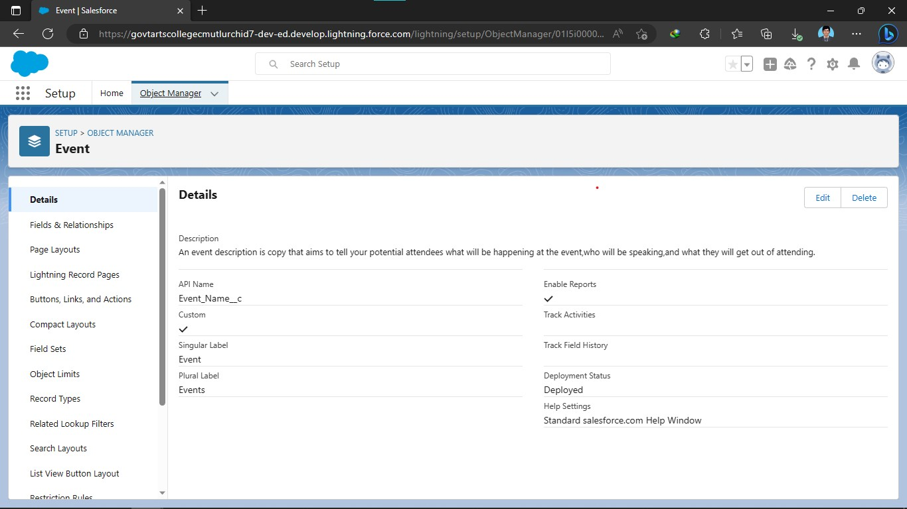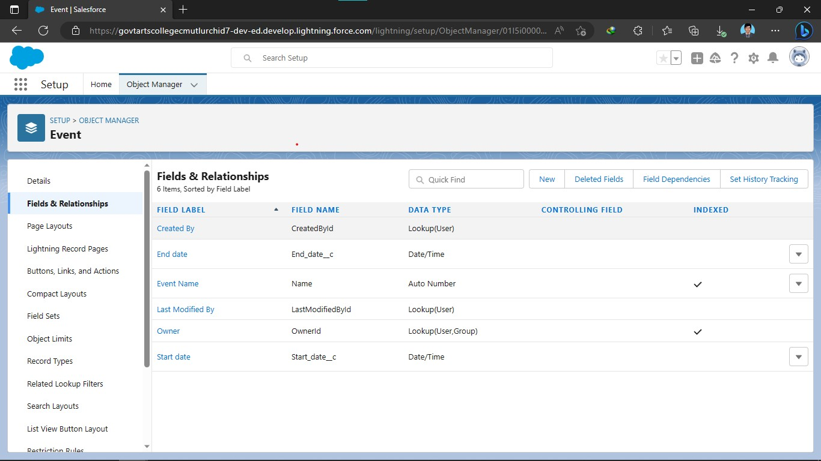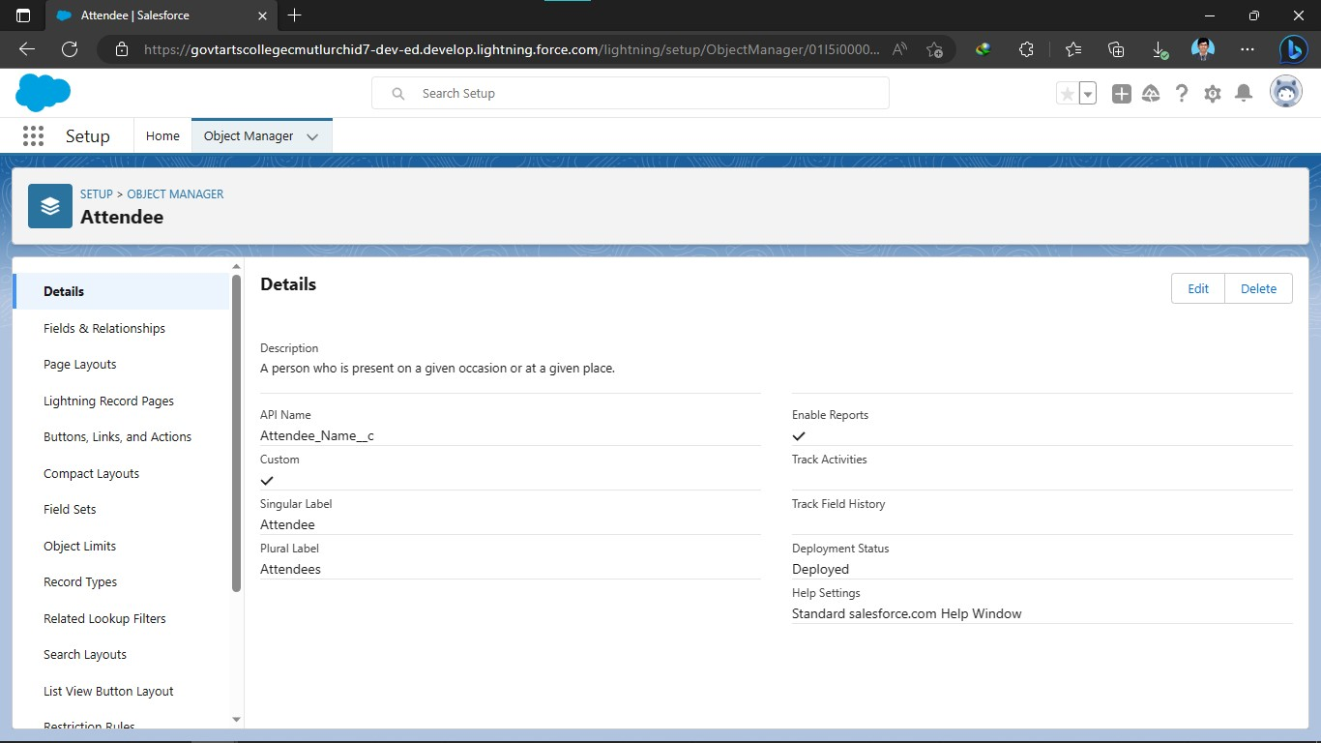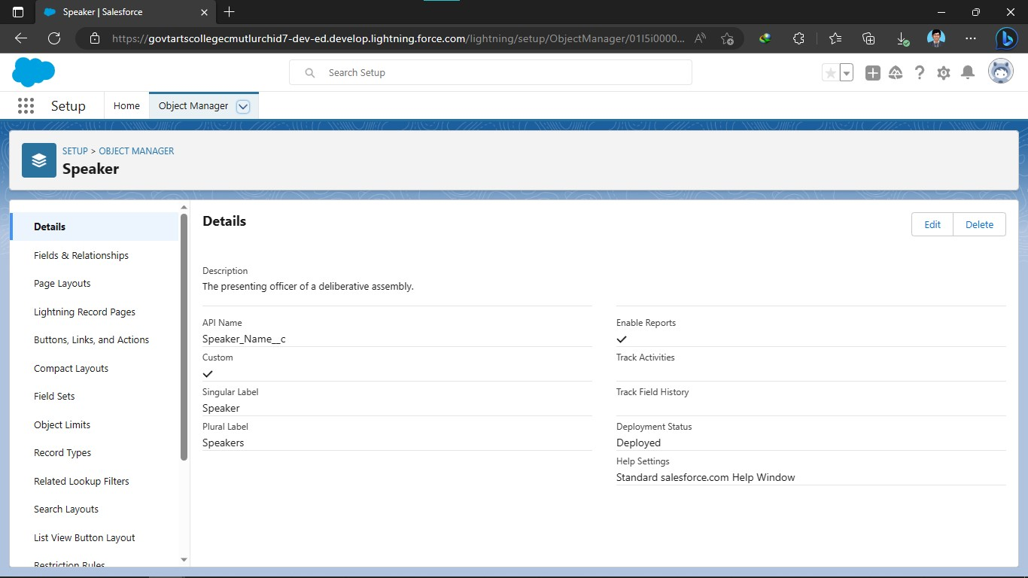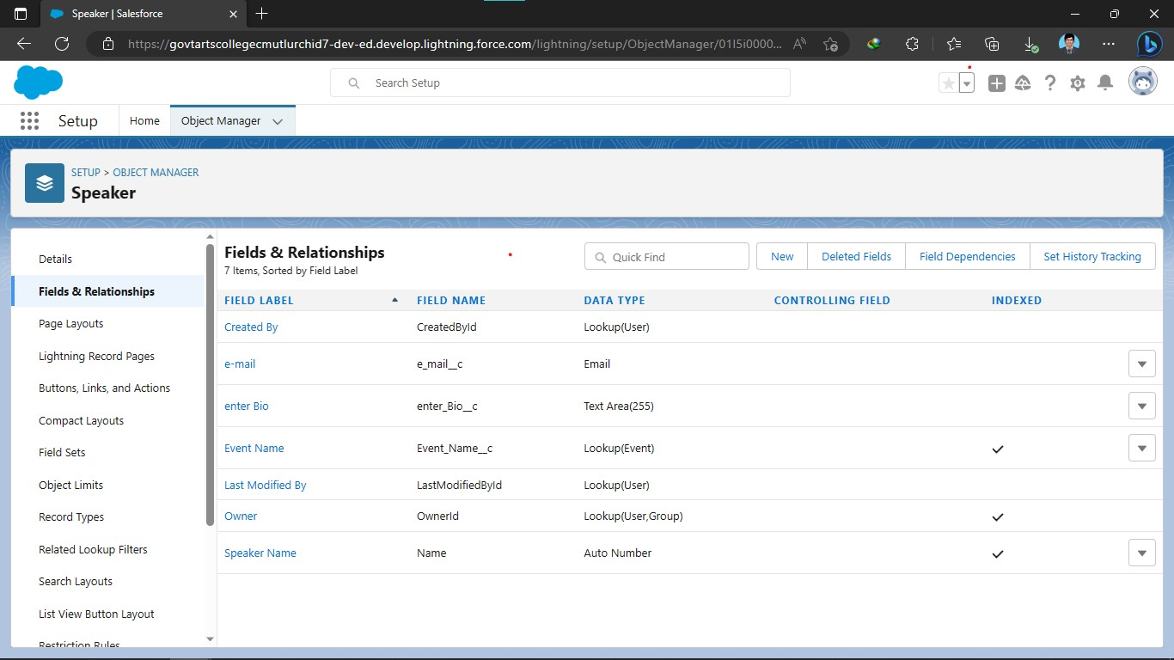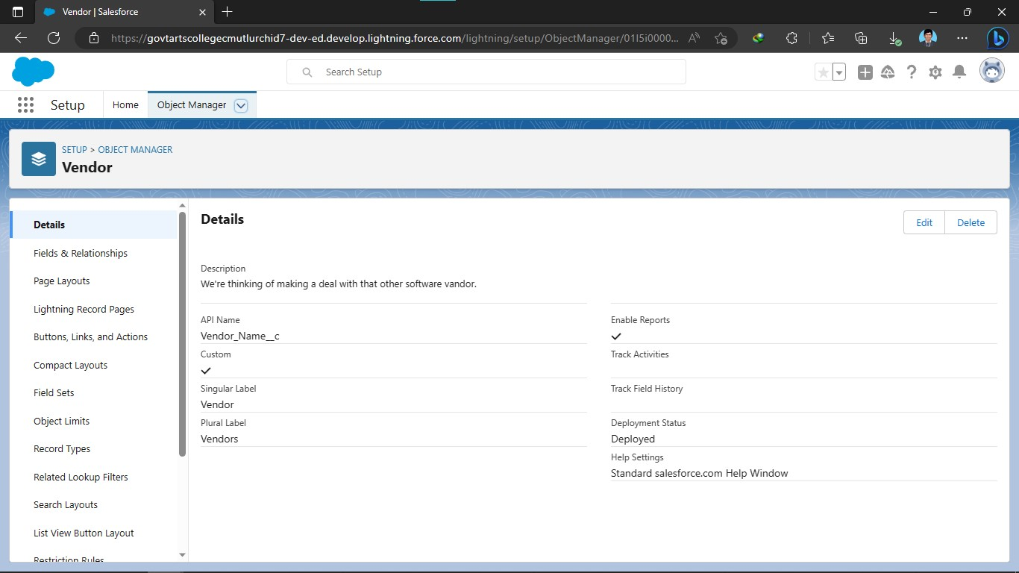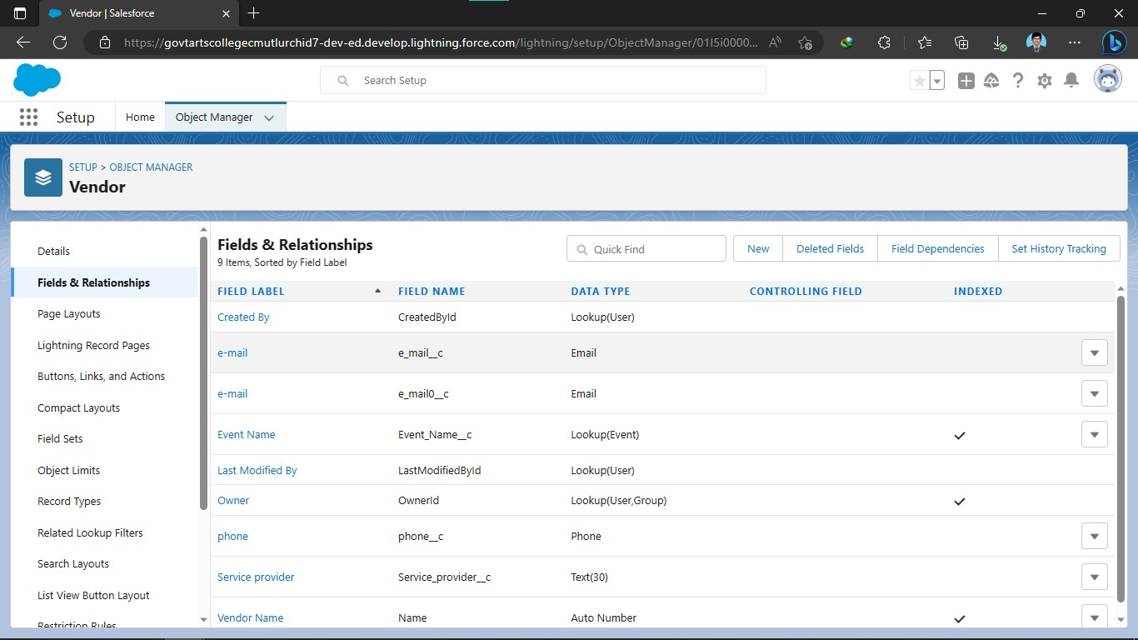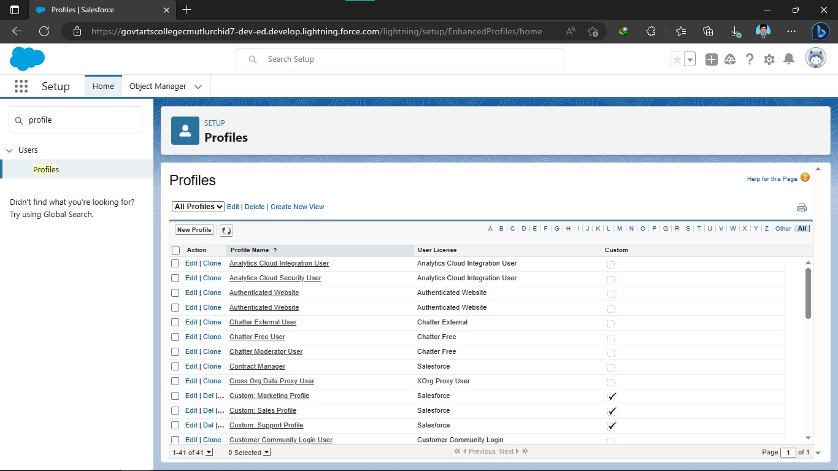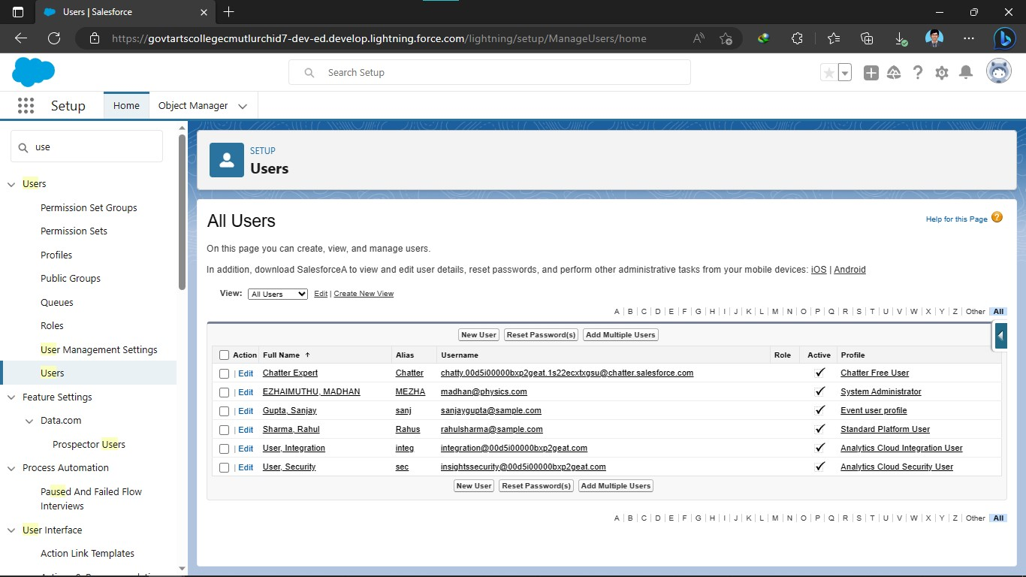

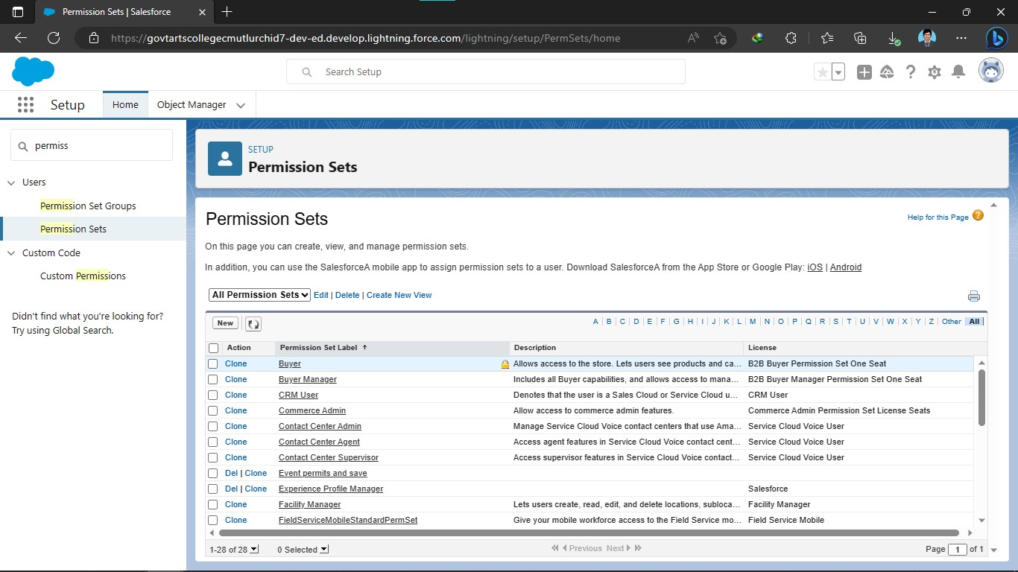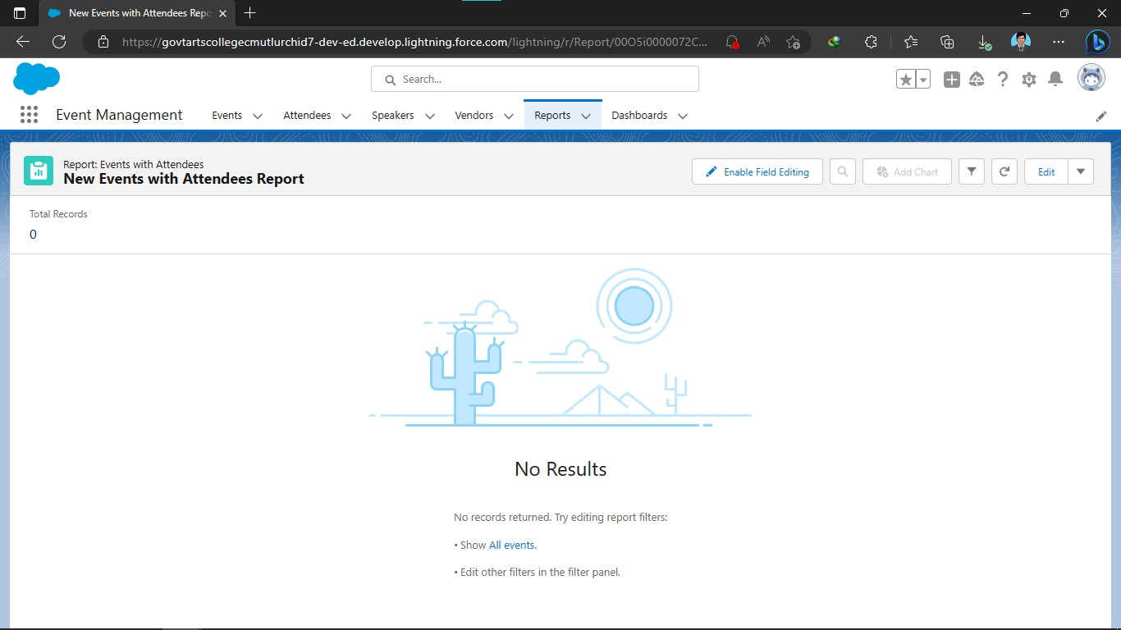

# Trailhead Profile Public URL

Team Lead - https://trailblazer.me/id/madhan000000

Team Member 1 -https://trailblazer.me/id/kiruthikrajan22

Team Member 2 –https://trailblazer.me/id/kkrishnamoorthy13

Team Member 3 –https://trailblazer.me/id/mamayavan

# ADVANTAGES & DISADVANTAGE.

# ADVANTAGES:

* Reduce time for finding location.

* User Friendly GUI.

* This system is effective and provide best of the cost to user.

* Save Time In Communication.

* Efficiently Manage Multiple Events.

# DISADVANTAGES:

* You need to pay them in addition to other event costs

* The event management come any does not know anything about your company unless you tell them.

* Budgeting problems are one of the most common challenges that event planners face is budgeting.

# APPLICATIONS

A truly comprehensive event management system will allow users and organizers to access and manage all aspects of an event, including registration, marketing, engagement, integrations, physical planning and preparation, reporting and analytics, and more.

On college and university campuses, events are happening all the time, whether student- or faculty-focused, and often through in-house or third parties and vendors. When these events take place, it is critical to use an event management system that offers full control and planning capabilities to ensure activities happen on time, in accommodating spaces and keeping in mind the safety of every attending. A comprehensive event solution will allow campus event planners to book large-scale events, communicate with service providers, and maintain a single source of record for repeatable, measurable events.

Event planners on university campuses must also consider student and faculty safety, especially now as large gathers have become more complicated in the wake of COVID-19. An event management system provides connection to campus police and other security factors to keep attendees safe and control crowds. An event management system can also help formalize sanitation procedures, ensure socially distant spacing, and more.

# CONCLUSION

In this project, we made attempt to effectively introduce the concept of event management systems already existing in the society. We then explain the concept of online event management systems which are already present. We describe the proposed system and explain the features implemented by our proposed system .We also give a brief overview of the technologies used during the development of our proposed system. This project can be further refined and extended by introducing new and more innovative features.

# FUTURE SCOPE

The scope of event management as a career in India is broad as the events and activations industry is one of the fastest growing industries in India.

The event management is the art of planning and organising and event that can be personal social educational corporate in nature.

Corporate events like board meetings conventions and business dinners are outsourced to event management companies seminars and conferences are important business events for the training of managers and employees.